**Kubernetes as a Service (Managed K8s)**

* Every Cloud provider offers k8s as a service
  + Azure = AKS
  + AWS = EKS
  + GCP = GKE
* K8s as a service basically means the master nodes will be managed by cloud provider

Typical k8s cluster  
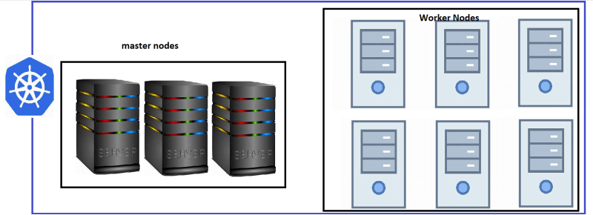

K8s as a Service  
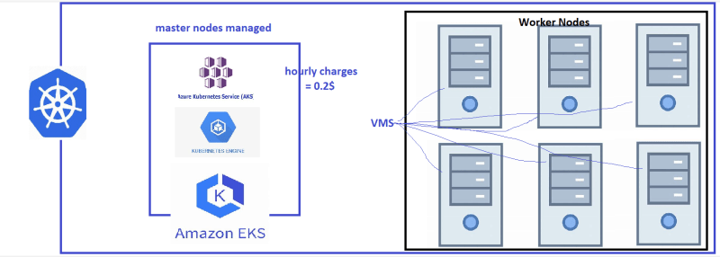

* Advantages:
  + less administration
  + nodes can be scaled
  + inbuilt support for cloud integrations
* In this course we will be using
  + AKS
  + EKS

**Setting up basic k8s cluster in Azure (AKS)**

* In this setups we configure kubectl on
  + dev systems

build servers  
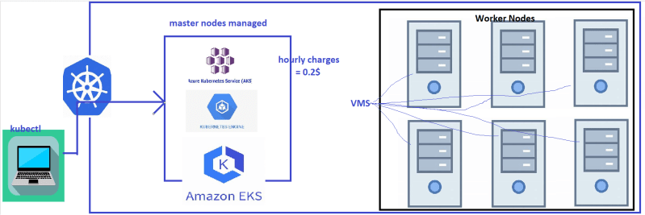

* install kubectl <https://kubernetes.io/docs/tasks/tools/> or we can use azure cli to set it up
* Install azure cli
* Execute az login
* <https://learn.microsoft.com/en-us/azure/aks/learn/quick-kubernetes-deploy-cli> for azure aks
* Create a resource group and continue according to docs <https://learn.microsoft.com/en-us/azure/aks/learn/quick-kubernetes-deploy-cli#create-a-resource-group>